**OS Lab  
Assignment  
UmairSolangi 2112203   
5C**

1. Find pages/lines/command containing keyword ‘log’

2. List all hidden files

3. Concatenate header.sh, body.sh, and footer.sh into index.sh

4. Use touch and echo to create file with text in it

5. Hide all files in the existing folder

6. Find the following

• find

• less

• “logs”

• file.ext

• /Desktop



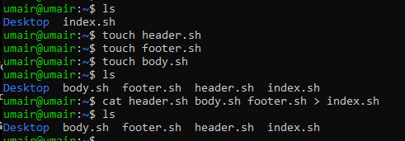

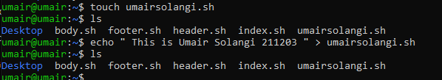

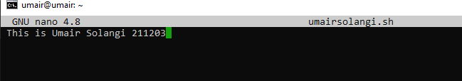

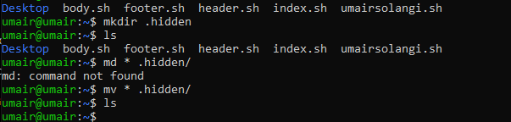

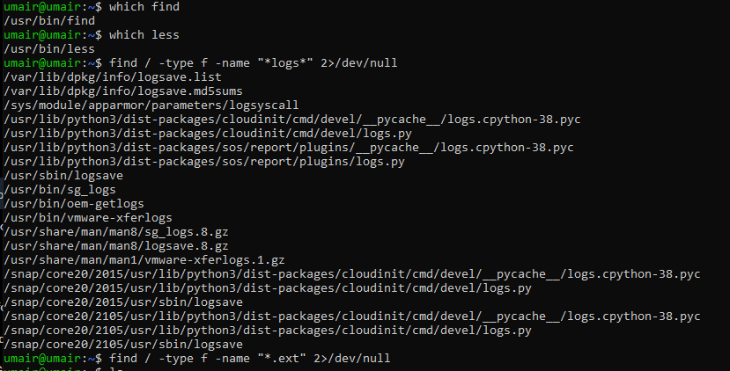



Tasks:

1. Create users based on your registration IDs.

2. Make a common folder to share among all students and faculties.

3. Restrict the execute on all shell files in common folder.







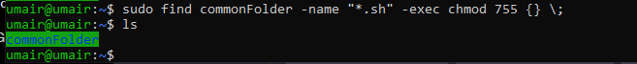

Tasks:

a) Create a short program of a kiosk for restaurant.

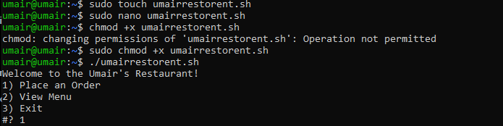

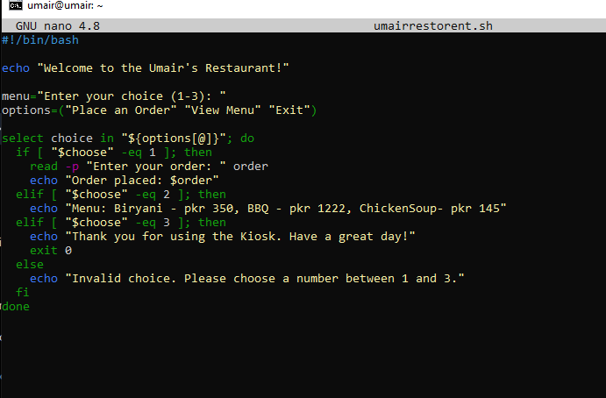

Tasks:

1. Complete the following tasks:

◦ Create new user called ‘guest’ with password ‘guest’

◦ Print the current directory

◦ Create folder called ‘project’ and provide read-only permissions to others

◦ Create file called ‘Main.html’ and provide permission as 755 or 644

◦ Create Groups as Students, LabAdmins, Faculty

◦ You may assign permission as Read-only to Students, Faculty with Read-only and Write-

only and LabAdmins as All

2. Create commonshare for Students and LabAdmins

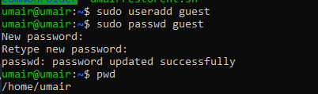

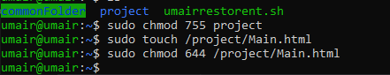

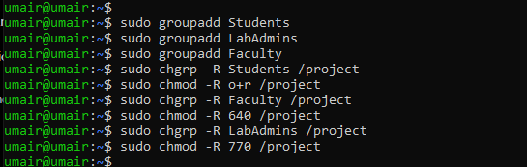

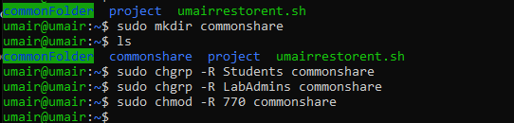

**Class Task:**

**1. Practice the provided code Burst Time**

**2. Calculate batch job process sequence for provided data**

**3. Print Job sequence with Job name and Burst Time**

